Sweet Beginnings Bakery
…and supplies too!!!
3535 Lincoln Highway
Thorndale, PA 10372-1007
Tel: 610-269-3969 Web Site: www.sharonssweetbeginnings.com
Email: sharon@sharonssweetbeginnings.com

“EVERYTHING FOR THE ART, CRAFT, AND BUSINESS OF CAKE DECORATING AND CANDY MAKING”

Normal Business Hours: Sunday - Monday CLOSED
Tuesday-Friday 8:00 am – 4:00 pm
Saturday 9:00 am – 2:00 pm

TERMS OF SALE AND INFORMATION

NEW USAACCOUNTS: No minimum order to ship.

All orders will be shipped Master Card, Visa or Money Order in Advance. Ask for invoice to be emailed through PayPal.
No COD’s.

All invoices are billed and payable in US Dollars.

TERMS OF SALE FOR NON-US ACCOUNTS: Payment with order, credit card (Master Card or Visa only through PayPal). No credit terms available outside the United States.

All invoices are billed and payable in US Dollars.

OPEN ACCOUNT: Terms are cash or credit card on pick up only.

Phone: 610-269-3969
Web Site: www.sharonssweetbeginnings.com
Email: Sharon@SharonsSweetBeginnings.com

SHIPPING CHARGES: FOB POINT OF ORIGIN

Charges for UPS/FEDEX Ground shipments are based on UPS/FEDEX Ground published rates and restrictions.
LTL (truck) shipments are sent prepaid and add using the carrier of our choice or collect if you specify the truck line.
Post Office shipments will be assessed a $5 handling fee in addition to postage for delivery to the Post Office. Non-standard pack items (pails & cake boxes) shipped via UPS/FEDEX Ground will be charged an additional handling fee per item as per UPS/FedEx Ground published rate.
PICK UP ORDERS: 24 HOUR MINIMUM ADVANCE NOTICE REQUIRED
Please call or email your orders Two Business Days BEFORE date of pickup to avoid long delays or disappointment. Add on to pickup orders will be filled on a time available basis and may not be available the same day.

BREAKAGE: Please refer to the instructions on the following page for handling damages.

RETURNS & SHORTAGES: WE DO NOT SELL ON CONSIGNMENT. EDIBLE products may NOT be returned (unless Sweet Beginnings error). Shopworn, priced, loose merchandise not in the original container or merchandise over 30 days old (from invoice date) may NOT be returned.

FOOD PRODUCTS ARE SHIPPED AT THE PURCHASERS RISK. WEATHER RELATED DAMAGES WILL NOT BE
CREDITED OR REPLACED. Please be advised the some non-food items may also be subject to weather related damage.

Unacceptable returns will be returned at the shipper’s expense or destroyed. Acceptable returned items are subject to a 15% restocking fee. Shortages must be reported within 5 days after receipt of merchandise. Please check carton & packing materials carefully as small items can easily be overlooked. Please pack returned merchandise carefully. Returned items must be received back in salable condition for credit to be issued.

PRICING: Orders are accepted on the condition that they are billed at price prevailing at the date of shipment.
Prices are subject to change without notice.

BACKORDERS & STOCK OUTS: Items that are temporarily out of stock are NOT backordered unless specifically requested at the time the order is placed. Backorders for less than $25 that are not full case items are automatically cancelled. Please re-order. Unshipped backorders will be cancelled after 30 days.

RETURNED CHECKS: A $25 returned check fee will be assessed to all checks returned by your bank as unpaid.

POLICY & PROCEDURES FOR DAMAGES, RETURNS AND SHORTAGES, ETC

Please report all damages, shortages, shipping errors to Sweet Beginnings via mail, phone or email upon discovery, within 3 days of receipt of merchandise or invoice.

DAMAGES

· Shipments via UPS/FEDEX Ground

If the shipment contains cartons that are obviously damaged, open, resealed, or re-boxed, please refuse the suspect cartons. You may accept the other cartons in the shipment and refuse only the cartons that are damaged open etc. Report "concealed" damages to Sweet Beginnings upon discovery. We will contact the carrier to arrange for an inspection of the damage at your location or have the carrier return the carton to us for inspection here.
NOTE: you MUST keep the original shipping cartons (with shipping labels intact) and the packing materials for any claim to be honored until an inspection has been performed or you are instructed otherwise by Sweet Beginnings personnel. We will issue you a credit or replacement and start claim proceedings upon notification that damage has occurred.

· Shipments via COMMON CARRIER (TRUCK)

Damages and carton shortages must be noted on the freight delivery receipt. Count the cartons and inspect the shipment carefully BEFORE signing the freight delivery receipt. Request that the driver note on the freight receipt any discrepancies or damages BEFORE paying or signing the freight bill. Claims for shortages or damages must be filed with the carrier by you if the shipment came "freight collect". DO NOT DEDUCT FROM CK INVOICE. Request a claim form from the
Carrier’s local office. Sweet Beginnings will file claims for shortages or damages on "prepaid" freight shipments. Please forward the delivery receipt (with the drivers notations) to us to process your claim. We cannot process your claim for damaged or missing cartons on common carrier shipments if no notation is made on the delivery receipt about discrepancies or damage.

PLEASE COUNT YOUR CARTONS AND INSPECT YOUR SHIPMENT BEFORE YOU SIGN THE DELIVERY RECEIPT.

SHORTAGES, OVERAGES or ERRORS

Please report shortages, overages, incorrect or defective merchandise to Sweet Beginnings upon receipt of the invoice. We will determine where an error occurred and if all cartons in the shipment were received. Credit or replacement product will then be issued. Authorized Return Service (ARS) tags will be issued for any overages, defective items, or items received due to a Sweet Beginnings error that you do not wish to keep. Please pack items being picked up by ARS carefully, so damage does not occur during the return.

RETURNS

We cannot issue ARS tags for items received due to YOUR error in ordering or that you do not like upon receipt. These items (except FOOD PRODUCTS) will be accepted for return and credit at your expense. Please pack returned items carefully within another carton (where applicable) to avoid damage during the return. Returned items must be in the original condition and packaging and received by us in a salable condition to be eligible for credit and must be returned within 30 days of purchase. A 15% restocking fee will be charged for qualifying customer returned items.
Unacceptable returns will be returned at your expense or destroyed.

NOTE: FOOD PRODUCTS (other than Sweet Beginnings error) MAY NOT BE RETURNED, so please order carefully.

Sweet Beginnings Cake & Candy Supply Catalog
3535 Lincoln Highway
Thorndale PA 19372-1007
Tel: 610-269-3969 Web Site: www.sharonssweetbeginnings.com
Email: sharon@sharonssweetbeginnings.com

“EVERYTHING FOR THE ART, CRAFT, AND BUSINESS OF CAKE DECORATING AND CANDY MAKING”

Regular Business Hours: Tuesday-Friday 9:00 am – 4:00 pm
Saturday 9:00 am – 2:00 pm

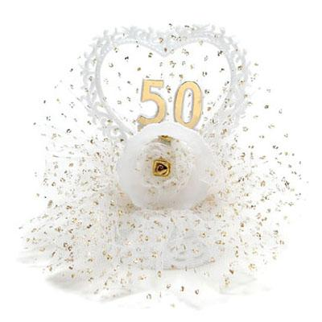
14-192G PETITE 50TH ANNIVERSARY 5-1/4" $ 9.50
14-192S PETITE 25TH ANNIVERSARY 5-1/4" $ 9.50
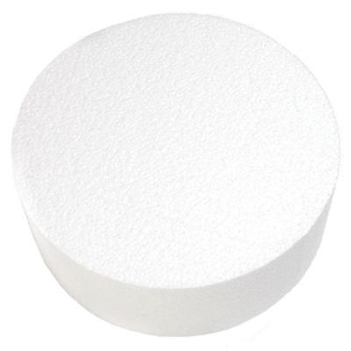

21-1204 CAKE DUMMY ROUND 4” X 4” $ 2.00
21-1206 CAKE DUMMY ROUND 6” X 4” $ 3.40
21-1208 CAKE DUMMY ROUND 8” X 4” $ 5.75
21-1210 CAKE DUMMY ROUND 10” X 4” $ 8.75
21-1214 CAKE DUMMY ROUND 12” X 4” $15.90
21-1216 CAKE DUMMY ROUND 14” X 4” $18.30
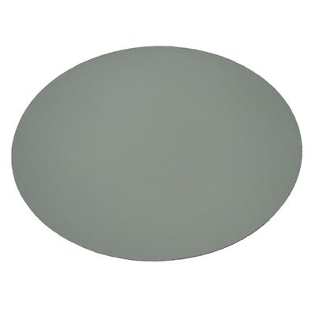
22-106 CARDBOARDS RD 6" COATED $ .25
22-108 CARDBOARDS RD 8" COATED $ .30
22-110 CARDBOARDS RD 10" COATED $ .40
22-112 CARDBOARDS RD 12" COATED $ .65
22-114 CARDBOARDS RD 14" COATED $ .85
22-116 CARDBOARDS RD 16" COATED $ 1.10
22-118 CARDBOARDS RD 18" COATED $ 1.65
22-120 CARDBOARDS RD 20" COATED $ 1.85
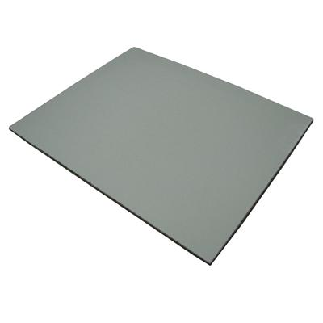
22-10913 RECT. WAXED 9-7/8 X 13-7/8 $ .60
22-11318 RECT. WAXED 13-7/8 X 18-7/8 $ 1.10
22-11725 RECT. WAXED 17-1/2 X 25-1/2 $ 1.45

23-108 DOILY GLASSINE 8" $ .15
23-110 DOILY GLASSINE 10" $ .25
23-112 DOILY GLASSINE 12" $ .30
23-114 DOILY GLASSINE 14" $ .80
23-116 DOILY GLASSINE 16" $ 1.15
23-118 DOILY GLASSINE 18" $ .75
23-120 DOILY GLASSINE 20" $ .80
23-1015 DOILY GREASE PROOF LINEN 11X15 $ .25
23-1520 GLASSINE DOILY 15" X 20 $ .45
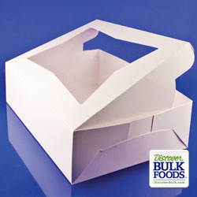
817542 1/4 SHEET CAKE BOX $ 2.45
817545 1/2 SHEET CAKE BOX $ 3.55
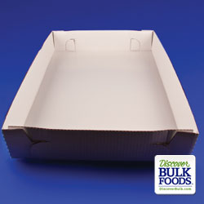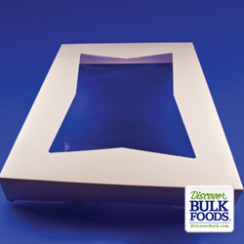
817470 FULL SHEET BOTTOM $ 4.90
817550 FULL SHEET CAKE TOP $ 3.75
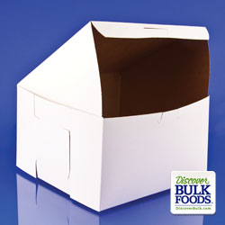
817286 8X8X5 BAKERY BOX $ .90
817304 10X10X2.5 BAKERY BOX $ .65
817310 10X10X5.5 BAKERY BOX $ 1.10
SO7487 12X12X5 BAKERY BOX $ 1.45
SO7488 14X14X5 BAKERY BOX $ 1.85
SO7489 16X16X5 BAKERY BOX $ 2.30
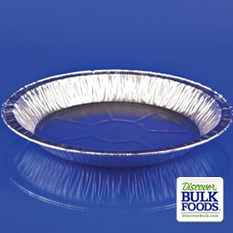
815082 10” DEEP PIE PAN $ .70
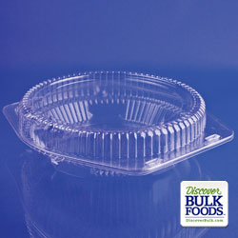
816118 10” HINGED PIE CONTAINER $ 1.05
SO7414 10’ HINGED PIE HI CONTAINER $ 1.15
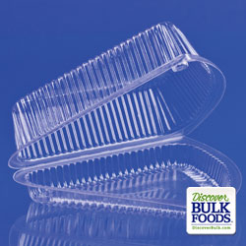
816122 SINGLE SLICE PIE WEDGE $ .50
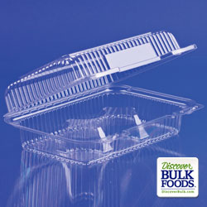
816314 6-CT CUPCAKE LO-DOME $ .55
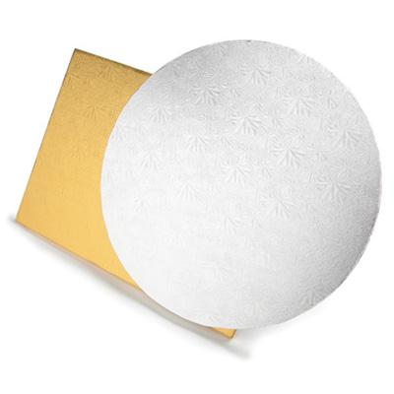
ROUND
27-2006 1/2" FOIL CAKE DRUM SILVER 6" $ 2.80
27-2008 1/2" FOIL CAKE DRUM SILVER 8" $ 3.30
27-2010 1/2" FOIL CAKE DRUM SILVER 10" $ 4.45
27-2012 1/2" FOIL CAKE DRUM SILVER 12" $ 4.90
27-2014 1/2" FOIL CAKE DRUM SILVER 14" $ 6.55
27-2016 1/2" FOIL CAKE DRUM SILVER 16" $ 8.80
27-2018 1/2" FOIL CAKE DRUM SILVER 18" $10.45
27-2020 1/2" FOIL CAKE DRUM SILVER 20" $13.70
SHEET
27-2047 1/2" CAKE DRUM 10X14 SILVER $ 3.80
27-2048 1/2" CAKE DRUM SILVER 18x26” $13.25
27-2049 1/2” CAKE DRUM 14X19” SILVER $ 7.80
SQUARE ~ REQUIRES SPECIAL ORDER
27-2050 SQUARE FOIL DRUM SILVER 10" $ 4.45
27-2052 SQUARE FOIL DRUM SILVER 12" $ 4.90
27-2054 SQUARE FOIL DRUM SILVER 14" $ 6.55
27-2056 SQUARE FOIL DRUM SILVER 16" $ 8.80
27-2058 SQUARE FOIL DRUM SILVER 18" $10.45
27-2060 SQUARE FOIL DRUM SILVER 20" $12.65
27-2049 1/2" CAKE DRUM 14X19" SILVER $ 7.80
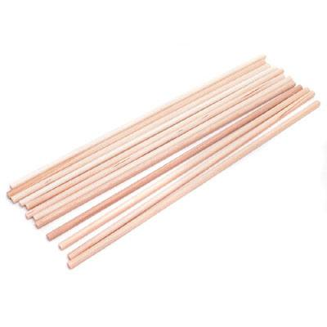
27-150 WOODEN DOWELS 1/4" PKG OF 12 $ 3.19
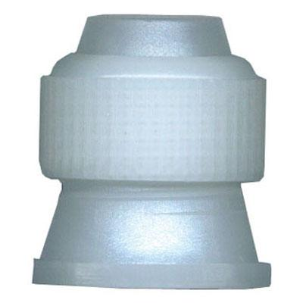
30-1000 STANDARD COUPLER $ .79
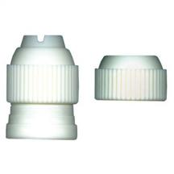
30-2000 LARGE 3-PIECE COUPLER $ 2.15

31-51 DISP REUS DECOR BAG/100 $19.95
31-55 12" DISP DEC BAG SMALL PKG/12 $ 6.30
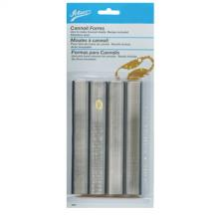
32-660 CANNOLI KIT $12.90

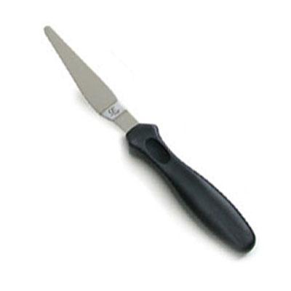
33-915 8” TAPERED SPATULA BLACK HANDLE $4.40
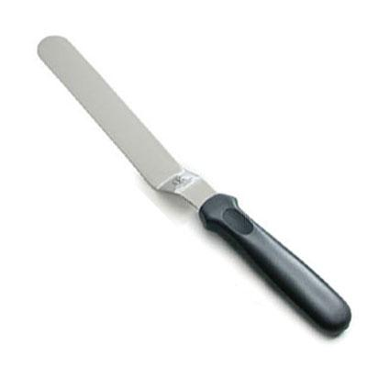
33-920 8” ANGLED SPATULA BLACK HANDLE $ 4.35
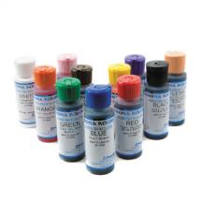
34-400 AIR BRUSH KROMA KOLOR 4 0Z $ 4.00 EA
(AIRBRUSH CLEANER, BLACK, BLUE, BROWN, FLESH,
GREEN, ORANGE, PINK, RED, VIOLET, YELLOW AND WHITE)
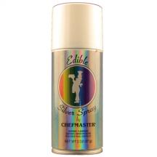
34-3615 CHEFMASTER EDIBLE SPRAY GOLD $11.95
34-3623 CHEFMASTER EDIBLE SPRAY PEARL $11.95
34-3635 CHEFMASTER EDIBLE SPRAY SILVER $11.95
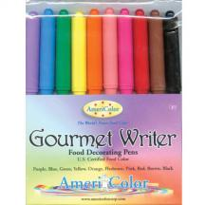
34-6010 FOOD COLOR PENS SET/10 $22.75
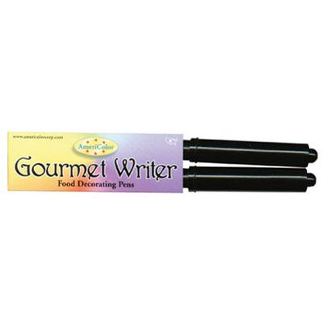
34-6015 BLACK FOOD COLOR PENS-2 FILLED $ 7.15
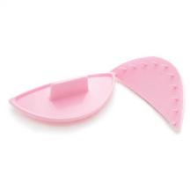
35-810 PINK GARLAND MARKERS $ 6.10
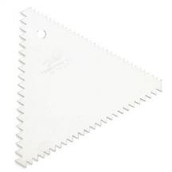
35-1446 DECORATOR COMB $ 1.05
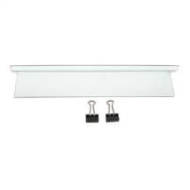
35-1480 CAKE BATTER SEPARATOR 10" $ 6.00
35-1482 CAKE BATTER SEPARATOR 12" $ 8.80
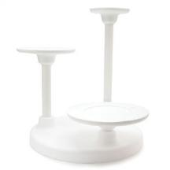
37-6501 3-TIER SINGLE USE CAKE STAND $31.15
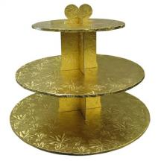
37-6700G 3-TIER CUPCAKE STAND-GOLD $13.85
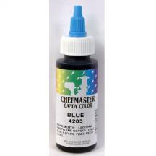
41-3275 CANDY COLOR 2OZ LIQUID BLACK $ 6.35
41-3276 CANDY COLOR 2 OZ LIQUID BLUE $ 6.35
41-3279 CANDY COLOR 20Z LIQUID GREEN $ 6.35
41-3280 CANDY COLOR 20Z LIQUID ORANGE $ 6.35
41-3281 CANDY COLOR 2OZ LIQUID PINK $ 6.35
41-3282 CANDY COLOR 2OZ LIQUID RED $ 6.35
41-3283 CANDY COLOR 20Z LIQUID VIOLET $ 6.35
41-3284 CANDY COLOR 2OZ LIQUID YELLOW $ 6.35
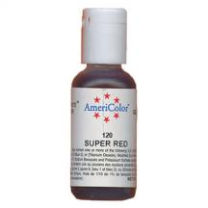
41-8001 SOFT GEL PASTE 3/4OZ SUPER BLACK $ 2.00
41-8002 SOFT GEL PASTE 3/4OZ ROYAL BLUE $ 2.00
41-8003 SOFT GEL PASTE 3/4OZ SKY BLUE $ 2.00
41-8004 SOFT GEL PASTE 3/4OZ CHOC BROWN $ 2.00
41-8010 SOFT GEL PASTE 3/4OZ TEAL $ 2.00
41-8011 SOFT GEL PASTE 3/4OZ LEAF GREEN $ 2.00
41-8013 SOFT GEL PASTE 3/4OZ ORANGE $ 2.00
41-8015 SOFT GEL PASTE 3/4OZ DUSTY ROSE $ 2.00
41-8017 SOFT GEL PASTE 3/4OZ PEACH $ 2.00
41-8018 SOFT GEL PASTE 3/4OZ BURGUNDY $ 2.00
41-8020 SOFT GEL PASTE 3/4OZ SUPER RED $ 2.00
41-8022 SOFT GEL PASTE 3/4OZ VIOLET $ 2.00
41-8030 SOFT GEL PASTE 3/4OZ REGAL PURPLE $ 2.00
41-8032 SOFT GEL PASTE 3/4OZ SOFT PINK $ 2.00
41-8033 SOFT GEL PASTE 3/4OZ MAROON $ 2.00
41-8034 SOFT GEL PASTE 3/4OZ NAVY BLUE $ 2.00
41-8035 SOFT GEL PASTE 3/4OZ GOLD $ 2.00
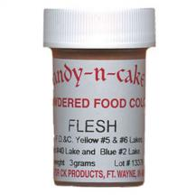
41-15025 POWDERED COLOR 3 GRAMS-FLESH $ 2.00
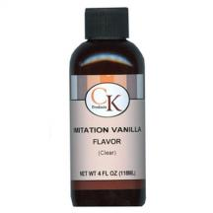
42-104 CLEAR VANILLA FLAVOR 4 OZ $ 3.75

42-108 VANILLA FLAVOR 8 OZ $ 5.15
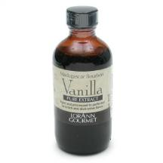
42-174 4 OZ VANILLA EXT MADAGASCAR $9.90

42-452 CREME BOUQUET FLAVORING 2 OZ $ 2.35
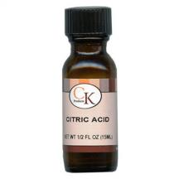
42-800 CITRIC ACID .5 OZ $ 3.75
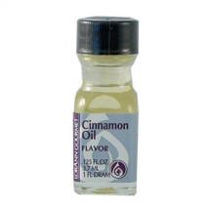
42-2010 1 DRAM LORANN-CINNAMON OIL $ 2.00
42-2020 1 DRAM LORANN-LEMON OIL $ 2.00
42-2050 1 DRAM LORANN-WNTRGRN $ 2.00
42-2060 1 DRAM LORANN-ORANGE OIL $ 2.00
42-2070 1 DRAM LORANN-PEPPERMINT OIL $ 2.00
42-2090 1 DRAM LORANN-SPEARMINT OIL $ 2.00
42-2100 1 DRAM LORANN-ANISE OIL $ 2.00
42-2150 1 DRAM LORANN-CHERRY FLAVOR $ 2.00
42-2160 1 DRAM LORANN-RASPBERRY FLAV $ 2.00
42-2180 1 DRAM LORANN-GRAPE FLAVOR $ 2.00
42-2190 1 DRAM LORANN-BUTTER RUM FLAV $ 2.00
42-2200 1 DRAM LORANN-BLACK WALNUT FL $ 2.00
42-2212 1 DRAM LORANN-CINNAMON ROLL $ 2.00
42-2270 1 DRAM LORANN-MAPLE FLAVOR $ 2.00
42-2320 1 DRAM LORANN-STRAWBRRY FLAV $ 2.00
42-2360 1 DRAM LORANN-BUBBLE GUM FLAV $ 2.00
42-2380 1 DRAM LORANN-AMARETTO FLAV $ 2.00
42-2410 1 DRAM LORANN-KEOKE FLAVOR $ 2.00
42-2500 1 DRAM LORANN-TROPICAL PUNCH $ 2.00
42-2510 1 DRAM LORANN-CREME DeMENTHE $ 2.00
42-2550 1 DRAM LORANN- CHAMPAGNE FLV $ 2.00
42-2560 1 DRAM LORANN-BRANDY FLAVOR $ 2.00
42-2580 1 DRAM LORANN-PEANUT BUTTER $ 2.00
42-2590 1 DRAM LORANN-MARSHMELLOW $ 2.00
42-2680 1 DRAM LORANN-CHEESECAKE FLAV $ 2.00
42-2800 1 DRAM LORANN-ORANGE CREME $ 2.00
42-2850 1 DRAM LORANN-MINT CHOC/CHIP $ 2.00

43-641PM PEOPLE MOLD FAMILY $59.95

43-1233 LUSTER DUST SUP GOLD $ 4.50

43-1402 HIGHLIGHTER(NONEDIBLE)-GOLD $ 5.40

43-1404 HIGHLIGHTER(NONEDIBLE)-SILVER $ 5.75
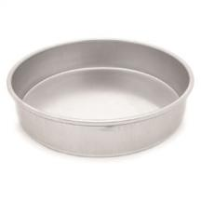
50-6 ROUND CAKE PAN 6" -2" DEEP $ 7.99
50-8 ROUND CAKE PAN 8" -2" DEEP $ 8.99
50-9 ROUND CAKE PAN 9" -2" DEEP $ 9.99
50-10 ROUND CAKE PAN 10" -2" DEEP $11.99
50-12 ROUND CAKE PAN 12" -2" DEEP $14.49
50-14 ROUND CAKE PAN 14" -2" DEEP $19.99
50-16 ROUND CAKE PAN 16" -2" DEEP $21.99
50-18 ROUND CAKE PAN 18" -2" DEEP $27.99
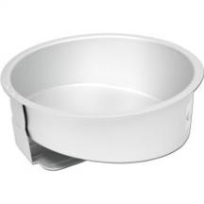
52-7006 MAD DADDER 6” ROUND $17.85
52-7008 MAD DADDER 8” ROUND $24.80
52-7010 MAD DADDER 10” ROUND $32.65
52-7012 MAD DADDER 12” ROUND $43.10
52-7014 MAD DADDER14” ROUND $53.57
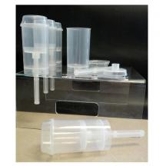
55-100 PUSH UP POP TUBE $ 1.50

58-2000 2" DOVE ON PICK-WHITE $ .20

58-6420 GOLD CROSS W/PICK $ .75

58-38056 PLASTIC BABIES (6) $ 2.25
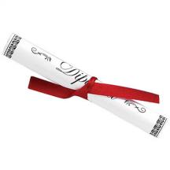
59-8000 PAPER GRADUATION DIPLOMA $ .35

59-8201 GRADUATION HAT-BLACK $ .75
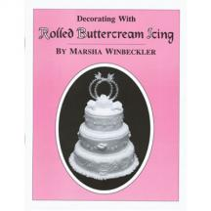
60-392 WINBECKLER M ROLLED BUTTERCRM BOOK $19.95
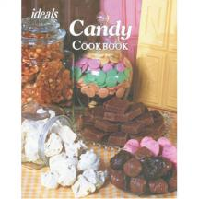
61-1025 IDEALS CANDY COOKBOOK $ 9.75
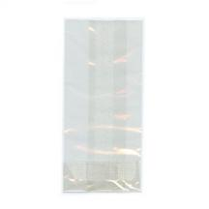***ALL CELLO BAGS ARE CLEAR – PKG 100***
65-21 CELLO BAGS 2X10 (PRETZEL ROD) $ 6.60
65-15 CELLO BAG 2.5 X 4.25 (LOLLI POP) $ 4.20
65-14 CELLO BAG 2.5 X 1 X 6 (¼ LB) $ 6.60
65-12 CELLO BAG BAGS 3X1.75X6.75 (1/2 LB) $ 7.65
65-1CELLO BAG 3.5X2.25X8.25 (1 LB) $ 9.90
65-2 CELLO BAG 4 X 2.75 X 9 (2 LB) $11.20
65-3 CELLO BAG 4X2.75X10.75 (3 LB) $12.15
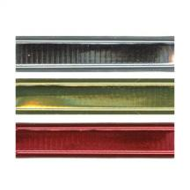
65-1100 1 ½” WIRE TIE-GOLD (1000) $25.95
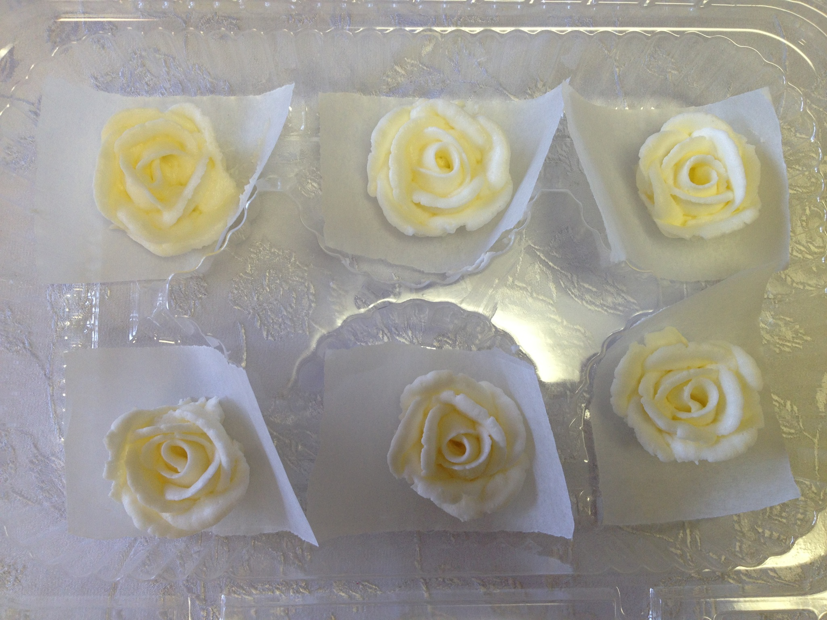
74-13815 (6)MED BUTTERCREAM ICING ROSE-WHITE $ 3.55
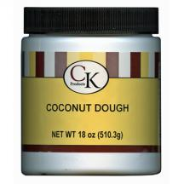
75-101 18OZ.COCONUT DOUGH $ 8.45
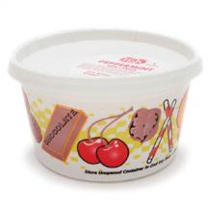
75-300 REDI CENTERS 1# BUTTERCREAM $ 7.20
75-306 REDI CENTERS 1# P.BUTTER $ 8.60
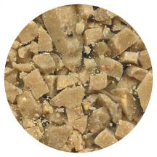
75-1001 CANDY CRUNCH-TOFFEE 1# $ 8.50
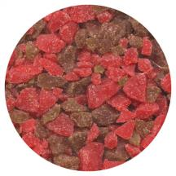
75-1130 CANDY CRUNCH-PEPP RED/GR 1# $ 6.25
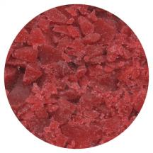
CANDY CRUNCH-RASPBERRY 1# $ 6.25
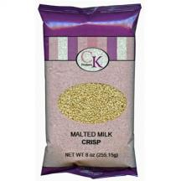
75-1900 MALTED MILK CRUNCH 8oz $ 4.75
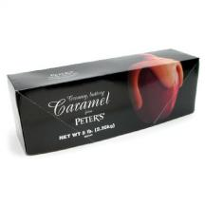
75-2000 PETER'S CARAMEL 5# LOAF $35.50
75-2001 1# PETER’S CARMEL BAG $ 7.25
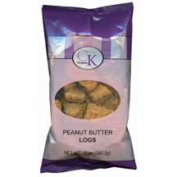
75-2102 PEANUT BUTTER LOGS 12 OZ. BAG $ 6.35
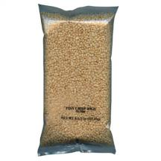
75-2106 TINY CRISP RICE 4.5 OZ BAG $ 2.30

75-2152 OREO COOKIE PIECES 10 OZ. BAG $ 9.10
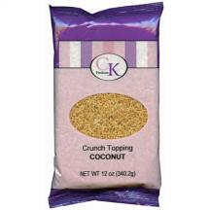
75-2853 CRUNCH 12OZ – COCONUT $ 6.50
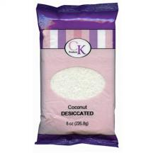
76-3010 DESICATED COCONUT 8 OZ $ 3.40
76-6502 INVERTASE 2 OZ $ 3.55
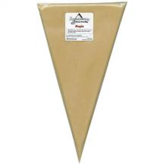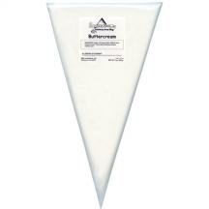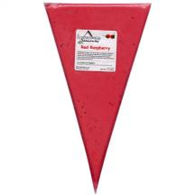
75-405 SQUEEZE-UMS 8 OZ MAPLE $ 4.00
75-411 SQUEEZE-UMS 8 OZ BUTTERCREAM $ 4.00
75-414 SQUEEZE-UMS 8 OZ RED RASPBERRY $ 4.00
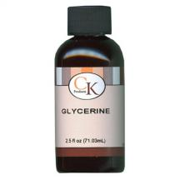
76-122 GLYCERINE 2.5 OZ $ 2.80

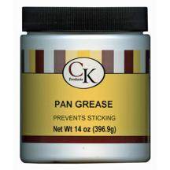
76-1011 PAN GREASE 14 OZ. TUB $ 7.75
76-1504 MERINGUE POWDER 4 OZ $ 5.60
76-5001 GLUCOSE 1# $ 5.60
76-6002 INVERT SUGAR 1.25# TUB $ 8.55
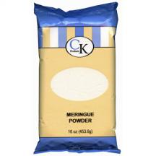
76-1501 MERINGUE POWDER 1 LB BAG $11.55
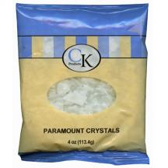
76-3204 PARAMOUNT CRYSTALS 4 OZ BAG $ 2.00
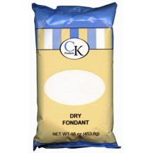
76-5501 DRY FONDANT 1# BAG $ 4.00
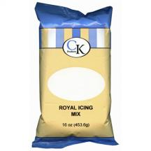
77-101 1# ROYAL ICING MIX $ 3.90
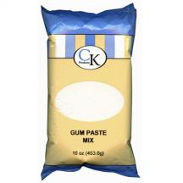
77-201 1# GUM PASTE MIX $ 4.85
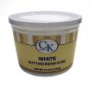
77-660 BUTTERCREAM ICING 3.5# $13.00
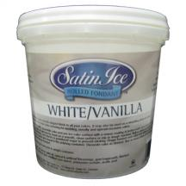
77-770 SATIN ICE ROLLED FOND. 5# WHT $36.95
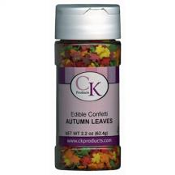
78-11313 2.8 OZ AUTUMN LEAVES $ 2.75
78-11402 2.8 OZ RED/GREEN TREES $ 2.75
78-11410 2.6 OZ WHITE SNOWFLAKES $ 2.75
78-11416 2.6 OZ GINGERBREAD MEN $ 2.75
78-11505 2.8 OZ RED/WHITE/BLUE STARS $ 2.75
78-11730 2.8 OZ POKER SHAPES $ 2.75
78-11975 2.8 OZ PINK RIBBON MIX $ 2.75
78-11980 2.8 OZ TIE A YELLOW RIBBON MIX $ 2.75
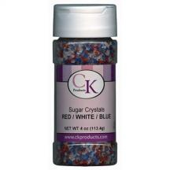
78-5043 4 OZ R CRYSTA-RED/WHT/BL $ 2.25
78-504B 4 OZ. COARSE SUGAR-BLUE $ 2.25
78-504G 4 OZ. COARSE SUGAR-GREEN $ 2.25
78-504K 4 OZ. COARSE SUGAR-BLACK $ 2.25
78-504O 4 OZ. COARSE SUGAR-ORANGE $ 2.25
78-504P 4 OZ. COARSE SUGAR-PINK $ 2.25
78-504R 4 OZ. COARSE SUGAR-RED $ 2.25
78-504V 4 OZ. COARSE SUGAR-VIOLET $ 2.25
78-504W 4 OZ. COARSE SUGAR-WHITE $ 2.25
78-504Y 4 OZ. COARSE SUGAR-YELLOW $ 2.25
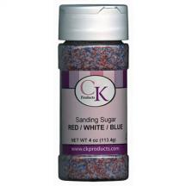
78-5053 4 OZ SANDING SUG R/WHT/BLU $ 2.25
78-505B 4 OZ SANDING SUGAR-BLUE $ 2.25
78-505G 4 OZ SANDING SUGAR-GREEN $ 2.25
78-505K 4 OZ SANDING SUGAR-BLACK $ 2.25
78-505L 4 OZ SANDING SUGAR-LAVENDER $ 2.25
78-505O 4 OZ SANDING SUGAR-ORANGE $ 2.25
78-505P 4OZ COURSE SUGAR-PINK $ 2.25
78-505R 4 OZ COURSE SUGAR-RED $ 2.25
78-505W 4 OZ SANDING SUGAR-WHITE $ 2.25
78-505Y 4 OZ SANDING SUGAR-YELLOW $ 2.25
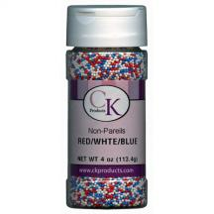
78-520A 4 OZ NON-PAREILS RED-WHT-BLUE $ 2.60
78-520B 4 OZ NON-PAREILS BLUE $ 2.60
78-520G 4 OZ NON-PAREILS GREEN $ 2.60
78-520K 4 OZ NON-PAREILS BLACK $ 2.60
78-520L 4 OZ NON-PAREILS LAVENDER $ 2.60
78-520N 4 OZ NON-PAREILS ORANGE $ 2.60
78-520P 4 OZ NON-PAREILS PINK $ 2.60
78-520R 4 OZ NON-PAREILS RED $ 2.60
78-520W 4 OZ NON-PAREILS WHITE $ 2.60
78-520Y 4 OZ NON-PAREILS YELLOW $ 2.60
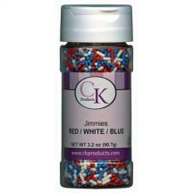
78-5304 3 OZ JIMMIES-RED WHITE & BLUE $ 2.25
78-530B 3 OZ JIMMIES-BLUE $ 2.25
78-530C 3 OZ JIMMIES CHOCOLATE $ 2.25
78-530G 3 OZ JIMMIES GREEN $ 2.25
78-530K 3 OZ JIMMIES BLACK $ 2.25
78-530L 3 OZ JIMMIES-LAVENDER $ 2.25
78-530O 3 OZ JIMMIES ORANGE $ 2.25
78-530P 3 OZ JIMMIES-PINK $ 2.25
78-530R 3 OZ JIMMIES RED $ 2.25
78-530W 3 OZ JIMMIES WHITE $ 2.25
78-530Y 3 OZ JIMMIES YELLOW $ 2.25
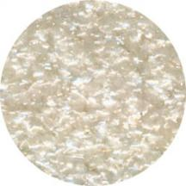
78-600W EDIBLE GLITTER 1/4 OZ. WHITE $ 2.25
78-604W EDIBLE GLITTER 4 OZ. WHITE $25.95
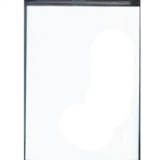
78-811 WAFER PAPER RECTANGLE 8" X 11" $ .25

78-A5102 ICING EYES 1/4" WH/BK $ 2.00
78-A5105 ICING EYES 3/8" WHT/BK $ 2.00
78-A5120 ICING EYES 1/2" WH/BK $ 2.00
78-A5131 ICING EYES 3/16" WH/BK $ 2.00
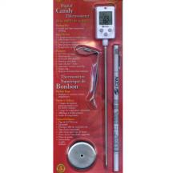
80-185 DIGITAL CANDY THERMOMETER $34.75

81-1 BOWL SCRAPER $ 1.05
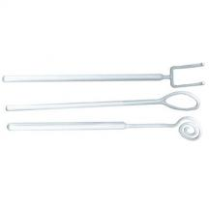
81-9 DIPPING FORK SET-COMM.WGT $ 8.15
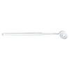
81-10 DIPPING FORK-SWIRL $2.85
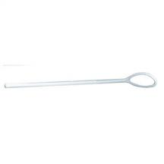
81-12 DIPPING FORK-OVAL $2.85
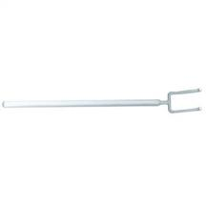
81-14 DIPPING FORK-TWO PRONG $2.85
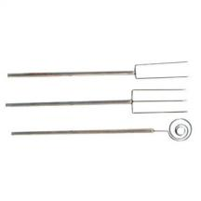
81-178 SS DIPPING TOOL SET $15.75
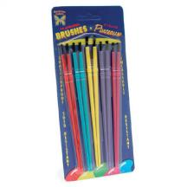
81-900 BRUSH-CANDY / SET $ 2.00
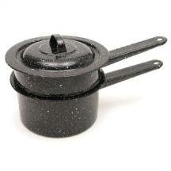
83-1 DOUBLE BOILER $29.40

85-234 WHITE CANDY CUP #4 $ 1.60
85-235 WHITE CANDY CUP #5 $ 1.70
85-236 WHITE CANDY CUP #6 $ 1.80
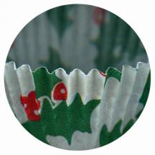
85-915 CHRISTMAS CANDY CUP #5 $ 2.50
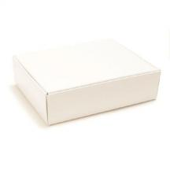
86-1071 1/4# DIE CUT BLANK $ .70
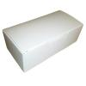
86-1080 1/2# WHITE CANDY BOX $ .45
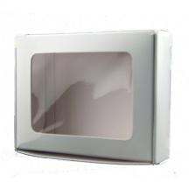
86-1081 1/4# WHITE CANDY BOX W/WINDOW $ .90
86-1110 1# WHITE CANDY BOX $ .60
86-1150 1-1/2# WHITE CANDY BOX $ .70
86-1180 2# WHITE CANDY BOX $ .90
86-1210 3# WHITE CANDY BOX $ 1.85

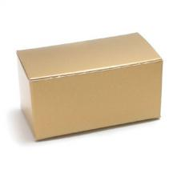
86-1230 MINI CANDY BOX – WHITE $ .65
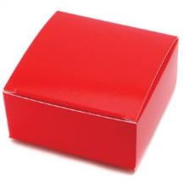
86-1260 2-1/2" SQ WHITE MAXI BOX $ .45
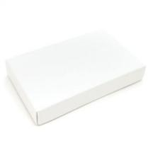
86-1370B 1/2# BASE WHITE $ .35
86-1400B 1# BASE WHITE $ .45
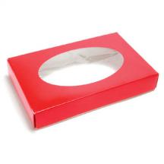
86-1372C 1/2# COVER WHITE W/WINDOW $ 1.35
86-1402C 1# COVER WHITE W/WINDOW $ 1.45
***SPECIAL ORDER COVERS***
86-1370COS ORNAMENTS 1/2# COVER $ 1.45
86-1400COS ORNAMENTS 1# COVER $ 1.65

86-2000 WHITE BOW BOX-APPROX 2X1X1 $ 1.35
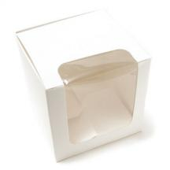
86-2030 APPLE WINDOW BOX 4x4x4" $ 1.25
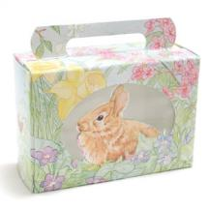
86-4425 1/2# BUNNY'N FLOWERS W/WINDOW $ .85
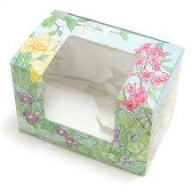
86-4460 1/4# EGG BOX W/WINDOW $ .85
86-4480 1/2# EGG BOX W/WINDOW $ .95
86-4500 1# EGG BOX W/WINDOW $ 1.25
86-4520 2# EGG BOX W/WINDOW $ 1.55
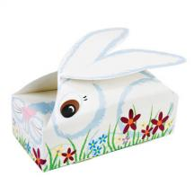
86-4650 BUNNY BUDDY 1/4# SNAP BOTTOM $ .55
86-4660 BUNNY BUDDY 1/2# AUTO BOTTOM $ .85
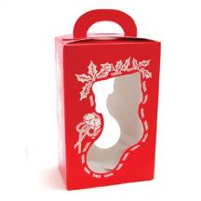
86-5200 XMAS STOCKING WIND BOX $ 1.65

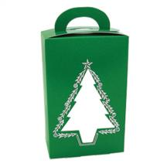
86-5210 XMAS TREE WINDOW BOX $ 1.65

86-5220 COOKIE BOX 1/2# RIBBON/HOLLY $ 1.50
86-5230 COOKIE BOX 1# RIBBON/HOLLY $ 1.60

87-06500 1/2# RED FOIL HEART W/GOLD STAMP $ 4.10
87-13600 1# RED FOIL HEART W/GOLD STAMP $ 6.75
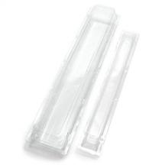
87-81220 ROSE BOX CLEAR SMALL SINGLE 21X2.5X2 $ .75

88-10 HOME MADE CANDIES LABEL ($.05 EACH) $ 7.65
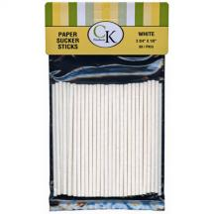
88-140 4 ½” LOLLIPOP STICKS/50 $ 2.05
88-162 6” LOLLIPOP STICKS/50 $ 3.00
88-51 8” LOLLIPOP STICKS/50 $ 4.30
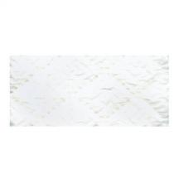
88-25521 CANDY PAD (FITS 1/4# BOX) $ .10
88-25551 CANDY PAD (FITS 1/2# BOX) $ .15
88-25511 CANDY PAD (FITS 1# BOX) $ .25
88-25500 CANDY PAD 19”X20” $1.40

89-144B 4 X 4 FOIL LT BLUE/125 $ 5.45
89-144G 4 X 4 FOIL GOLD/125 $ 5.45
89-144K 4 X 4 FOIL PINK/125 $ 5.45
89-144N 4 X 4 FOIL GREEN/125 $ 5.45
89-144R 4 X 4 FOIL RED/125 $ 5.45
89-144S 4 X 4 FOIL SILVER/125 $ 5.45
89-166G 6 X 6 FOIL GOLD/125 $10.40
89-166S 6 X 6 FOIL SILVER/125 $10.40
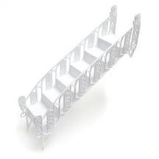
29-500 BRIDGE STAIRS WHITE $ 5.40
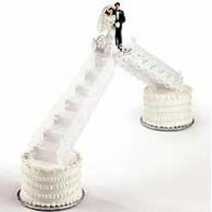
205-2109 WEDDING STAIRS & PLATFORM $12.99

302-6 DEC.PRF.SEPERATOR PLATE 6-IN $ 2.99
302-7 DEC PRF SEPERATOR PLATE 7-IN $ 2.99
302-8 DEC.PRF.SEPERATOR PLATE 8-IN $ 3.99
302-9 DEC PRF SEPERATOR PLATE 9-IN $ 4.29
302-10 DEC.PRF.SEPERATOR PLATE 10-IN $ 4.99
302-11 DEC PRF SEPERATOR PLATE 11-IN $ 5.29
302-12 DEC.PRF SEPERATOR PLATE 12-IN $ 5.99
302-13 DEC PRF SEPERATOR PLATE 13-IN $ 6.29
302-14 DEC.PRF.SEPERATOR PLATE 14-IN $ 6.99
302-15 DEC PRF SEPERATOR PLATE 15-IN $ 7.99
302-16 DEC.PRF.SEPARATOR PLATE 16 IN $ 9.99
302-18 DEC.PRF.SEPERATOR PLATE 18-IN $12.99
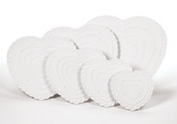
302-60 8 IN HEART SEPARATOR PLATE $ 3.99
302-61 10 IN HEART SEPARATOR PLATE $ 4.99
302-62 12 IN HEART SEPARATOR PLATE $ 5.99
302-63 14 IN HEART SEPARATOR PLATE $ 6.99
302-64 16 IN HEART SEPARATOR PLATE $ 9.99
302-65 18 IN HEART SEPARATOR PLATE $12.99
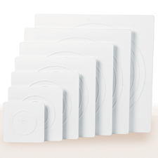
302-1801 6" SQ PLATE DEC.PREFERRED $ 3.99
302-1802 8" SQ PLATE DEC.PREFERRED $ 4.99
302-1803 10" SQ PLATE DEC.PREFERRED $ 5.99
302-1804 12" SQ PLATE DEC.PREFERRED $ 6.99
302-1805 14" SQ PLATE DEC.PREFERRED $ 7.99
302-1806 16" SQ PLATE DEC.PREFERRED $10.99
302-1807 18" SQ PLATE DEC.PREFERRED $13.99
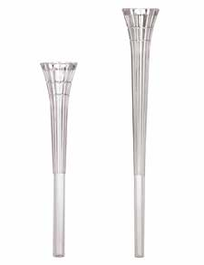
303-2322 7" CRYSTAL SPIKED PILLARS 4/PK $ 4.99
303-2324 9" CRYSTAL SPIKED PILLARS 4/PK $ 5.99


303-4000 7" PILLARS W/RINGS $ 3.79
303-4001 9" PILLARS W/RINGS $ 3.99
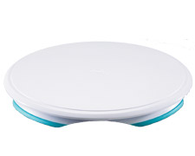
307-303 TRIM N TURN PLUS CAKE TURNTABLE $14.99
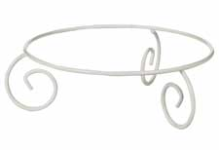
307-861 SATELLITE GARDEN CAKE STAND $49.49
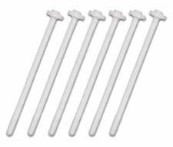
399-762 PLASTIC PEGS (PKG OF 12) $ 1.49
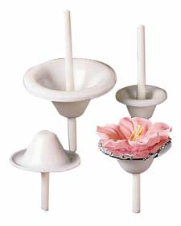
403-9444 8 PIECE LILY NAIL SET $ 2.49

404-5125 12” FEATHERWEIGHT DEC BAG $ 5.79
404-5140 14” FEATHERWEIGHT DEC BAG $ 6.79
404-5168 16” FEATHERWEIGHT DEC BAG $ 8.49
404-5184 18” FEATHERWEIGHT DEC BAG $ 9.49
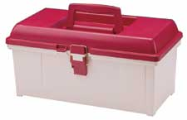
409-860 TOOL CADDY-MAROON/IVORY $26.99
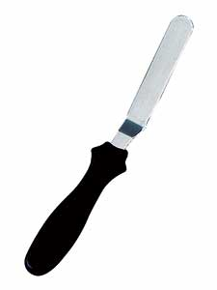
409-6012 8” ANGLED SPATULA $ 4.79
409-6024 13” ANGLED SPATULA $ 6.79
409-6036 15” ANGLED SPATULA $10.49
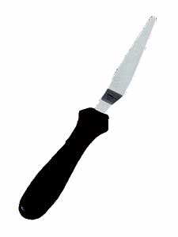
409-6003 8” TAPERED SPATULA $ 4.29
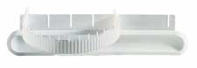
409-812 GARLAND MARKER (WILTON) $ 4.79

417-1199 WILTON FLOWER LIFTER $ 3.49

902-1232 CAKE DECORATING FOR BEGINNERS $ 3.99

902-1375 USES OF DECORATING TIPS $ 9.99
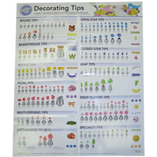
909-192 DECORATING TIPS POSTER $ 6.99
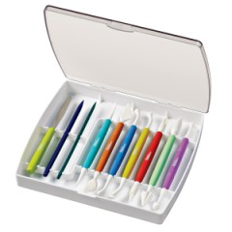
1907-11071 10-PIECE GUM PASTE TOOL SET $34.99
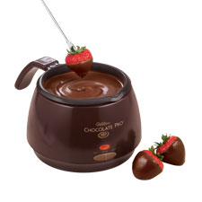
2104-9004 CHOC PRO CHOC MELTER $34.99
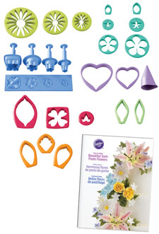
2109-0054 GUM PASTE FLOWER CUTTER SET $29.99
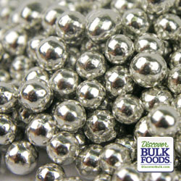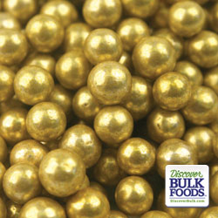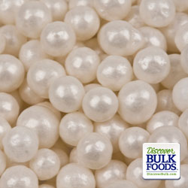
168900 #5 SILVER DRAGEES $ 4.00
168905 #5 GOLD DRAGEES $ 4.00
168915 #5 WHITE PEARLS $ 4.00
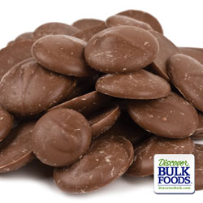
224043-1 1# BAG MERCKENS COCOA LITE $ 4.35
224043-3 3# BAG MERCKENS COCOA LITE $12.75
224043-5 5# BAG MERCKENS COCOA LITE $21.50
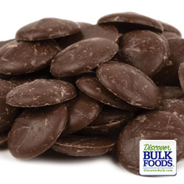
224048-1 1# BAG MERCKENS COCOA DARK $ 4.35
224048-3 3# BAG MERCKENS COCOA DARK $12.75
224048-5 5# BAG MERCKENS COCOA DARK $21.50
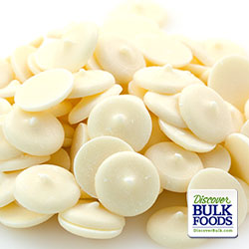
224051-1 1# BAG MERCKENS WHITE $ 4.35
224051-3 3# BAG MERCKENS WHITE $12.75
224051-5 5# BAG MERCKENS WHITE $21.50
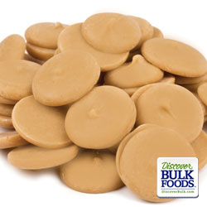
224101 1# BAG MERCKENS P BUTTER $ 5.35
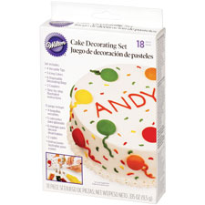
2104-2530 STARTER DECORATING SET $ 7.99
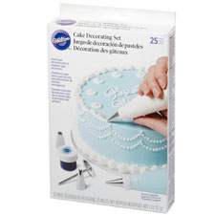
2105-2536 BASIC DECORATING SET $12.99
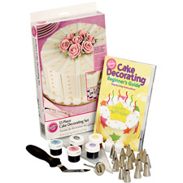
2105-2546 SUPREME DECORATING SET $32.99
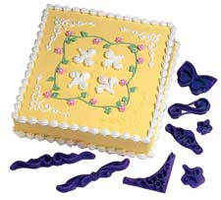
2104-3112 DESIGNER PATTERN PRESS $ 6.99

2104-3160 DECORATOR FAVORITE 12PC PRESS $ 6.99
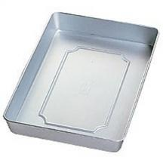
2105-1308 9 X 13 SHEET CAKE PAN $12.99
2105-182 12 X 18 SHEET CAKE PAN $19.99
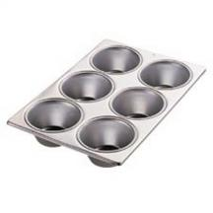
2105-1820 JUMBO MUFFIN PAN $18.99

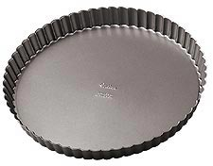
2105-442 9” TART/QUICHE PAN $11.99

2105-606 DEC PREF HEART PAN SET $49.99

2105-0783 PILLOW PAN SET $49.99
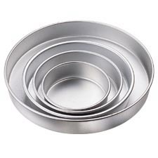
2105-2101 ROUND PAN SET $39.99
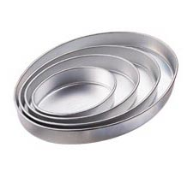
2105-2130 OVAL PAN SET $49.99
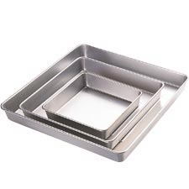
2105-2132 SQUARE PAN SET $49.99
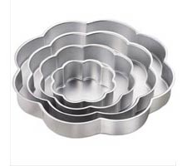
2105-2134 PETAL PAN SET $49.99
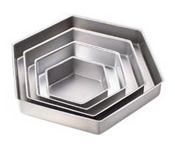
2105-3572 HEXIGON PAN SET $49.99
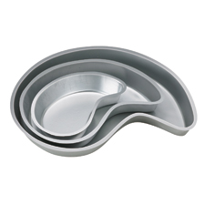
2105-4039 PAISLY PAN SET $49.99
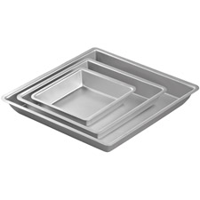
2105-4204 DIAMOND PAN SET $49.99
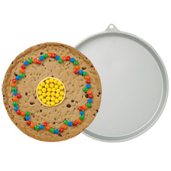
2105-6201 GIANT ROUND COOKIE PAN $ 7.99

2105-6203 GIANT HEART COOKIE PAN $ 7.99
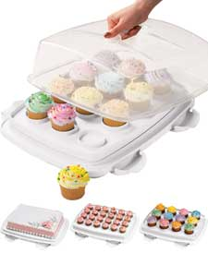
2105-9958 3 IN 1 CAKE CADDY $19.99
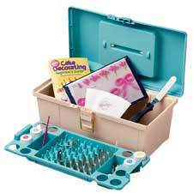
2109-859 50 PIECE TOOL CADDY SET $61.99

Coming Soon….

Bakery Ingredients

Cake Pan Rental Section

CAKE PAN RENTALS

$5.00 for each cake pan ~ Cake pans must be returned no later than the following Tuesday or pay an additional $5.00 rental. Credit Card information will be held to assure our cake pans are returned. $100.00 will be charged if the cake pan isn’t returned within 7 days of pick up.

FREE Cake Pan Rental Certificate with the exchange of your gently used Wilton Cake Pan. With or without instructions!

Candy Molds
VALENTINE

EASTER

HALLOWEEN

CHRISTMAS

CLASSIC SHAPES

SPORTS

RELIGIOUS

ALL OCCASION

ANIMALS

ANNIVERSARY

BABY

BEARS

BIRDS

BIRTHDAY

BUSINESS CARDS

BALLOONS/CLOWNS
FOR MEN

FISH/FROGS/NAUTICAL
262
FLOWERS&BUTTERFLY

FRAMES

FRUIT & FOOD

GAMES & GAMBLING

GRADUATION
276
HOME

FARM

FOR WOMEN

MILITARY

MUSIC

LETTERS & NUMBERS
284
PATRIOTIC
286
PROFESSIONS
288
ST. PATRICK’S DAY

STATES
290
TOYS

TRANSPORTATION
294
WEDDING
296
WESTERN

ZODIAC
298
MINI MOLDS

CLIP MOLDS
300
CHOCOPICKS

CUSTOM CHOCOLATE MOLDS
Chocolate molds can be made to your specifications or you can ask for our recommendations. Personalized Mint or Business Card molds are also available. Allow 10-14 working days for a prototype and 14-18 working days for finished molds.

